Chapter 8 – Preparing Windows 11 for Wazuh

Learning Objectives
After completing this chapter, you will be able to:
- Prepare Windows 11 for security monitoring.
- Understand why Windows needs additional configuration before connecting to Wazuh.
- Review Microsoft Defender settings.
- Enable Windows auditing.
- Enable PowerShell logging.
- Review Windows Firewall.
- Install the Wazuh Agent.
- Verify communication between the Windows endpoint and the Wazuh Manager.
📌 Note: By default, Windows does not generate every security event that security analysts need. This chapter enables important logging features so Wazuh can collect richer security information.

8.1 Why Prepare Windows for Wazuh?
Installing the Wazuh Agent alone is not enough.
To build a useful Blue Team lab, Windows should generate security events that Wazuh can collect and analyze.
Preparing Windows ensures that:
- Security events are logged.
- PowerShell activity is recorded.
- Authentication events are available.
- Microsoft Defender events are visible.
- The Wazuh Agent receives useful information.

8.2 Microsoft Defender
Windows Defender is Microsoft's built-in antivirus solution.
Open:
Windows SecurityVirus & Threat Protection
Review the following settings:
- Real-Time Protection
- Cloud-Delivered Protection
- Automatic Sample Submission
- Tamper Protection

Why Keep Defender Enabled?
Defender generates valuable security events.
Examples:
- Malware detected
- Malware removed
- Scan completed
- Quarantine action
These events can later be viewed in Wazuh.

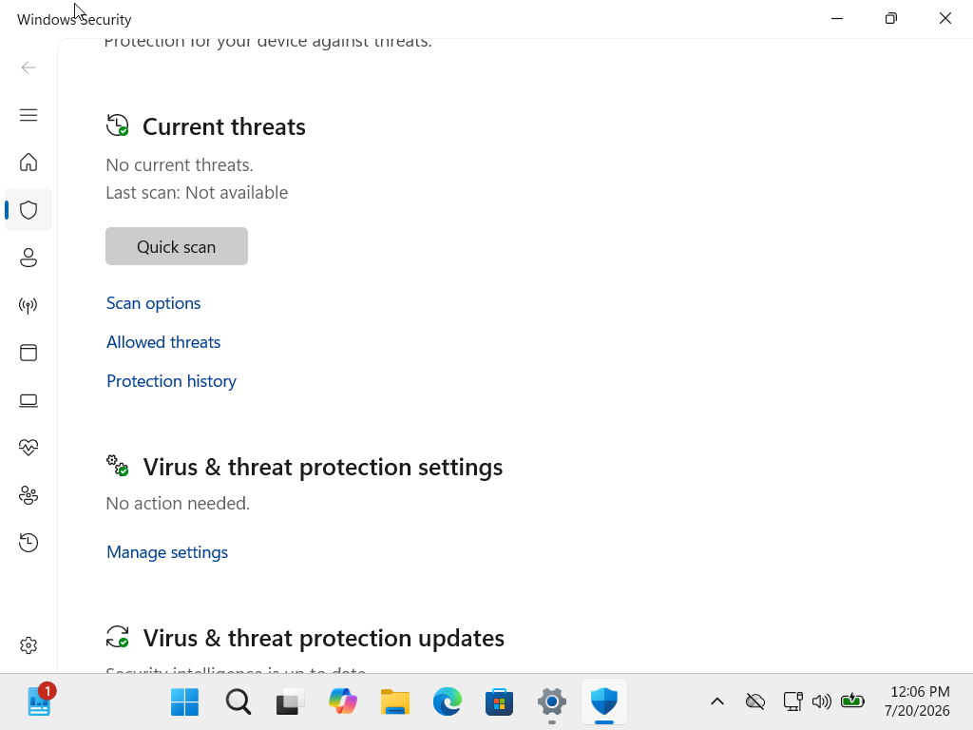

8.3 Windows Firewall
Open:
Windows SecurityFirewall & Network Protection
Verify that:
- Domain Profile
- Private Profile
- Public Profile
are enabled.

Why?
The firewall protects the endpoint from unauthorized network connections.
Disabling the firewall should only be done temporarily for troubleshooting in a controlled lab.
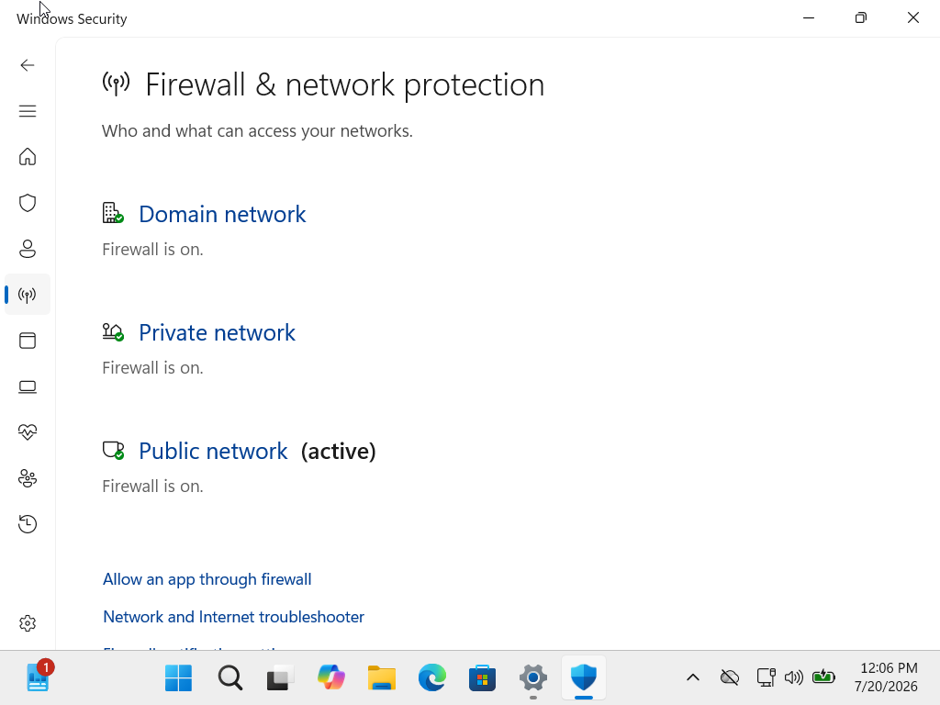

8.4 Windows Auditing
What is Auditing?
Auditing tells Windows which security events should be recorded.
Examples include:
- Successful logins
- Failed logins
- Account creation
- Password changes
- Object access
Without auditing, many important events will never appear in Event View

8.5 Review Local Security Policy
Open:
Win + Rsecpol.msc
Navigate to:
Security SettingsAdvanced Audit Policy Configuration
Here you can review categories such as:
- Account Logon
- Logon/Logoff
- Object Access
- Policy Change
- Privilege Use
- System
- Detailed Tracking
📌 Note: Some editions of Windows, such as Home, do not include the Local Security Policy editor (secpol.msc). Windows 11 Pro is recommended for this lab.

8.6 PowerShell Logging
PowerShell is widely used by:
- Administrators
- Blue Teams
- Attackers
Monitoring PowerShell activity helps detect suspicious behavior.
Examples:
- Downloading scripts
- Running encoded commands
- Executing administrative tasks

8.7 Event Viewer Verification
Open:
eventvwr.msc
Verify the following logs exist:
- Application
- Security
- System
- Setup
These logs will later be monitored by Wazuh.
8.8 Installing the Wazuh Agent
The recommended method is to use the Wazuh Dashboard.
Navigate to:
DashboardAgentDeploy New Agent
Select:
Windows
The Dashboard generates the correct installation command for your Wazuh version.
📌 Why Use the Dashboard?
The deployment wizard automatically generates commands that match your installed Wazuh version, reducing compatibility issues.

Screenshot Placeholder
[Screenshot Here – Deploy New Agent Wizard]

8.9 Running the Installer
Run the generated installation command with administrative privileges.
During installation, provide:
Setting | Example
Manager Address | 192.168.56.20
Agent Name | Windows11-Lab
Agent Group | Default
The installer will:
- Install the Wazuh Agent
- Configure communication
- Register the endpoint
- Create the Windows service

Screenshot Placeholder
[Screenshot Here – Wazuh Agent Installation]

8.10 Verify the Wazuh Agent Service
Open:
services.msc
Locate:
Wazuh Agent
Verify the status is:
Running

Screenshot Placeholder
[Screenshot Here – Wazuh Agent Service Running]

8.11 Verify Communication
Return to the Wazuh Dashboard.
Navigate to:
DashboardAgents
Expected result:
Windows11-Lab
Status
Active
If the agent appears as Active, communication with the Wazuh Manager is working correctly.

Communication Workflow
Windows EventWazuh AgentEncrypted ConnectionWazuh Manager
IndexerDashboardSOC Analyst

Screenshot Placeholder
[Screenshot Here – Windows Agent Active in Dashboard]

8.12 Generate a Test Event
To verify the connection:
- Log out and log back into Windows.
- Open Event Viewer and confirm a new login event appears.
- Wait a few moments.
- Search for the event in the Wazuh Dashboard.
This confirms that:
- Windows created the event.
- The Wazuh Agent collected it.
- The Manager analyzed it.
- The Dashboard displayed it.

Screenshot Placeholder
[Screenshot Here – Login Event in Wazuh Dashboard]

8.13 Common Problems
Problem
Agent Not Appearing
Possible Causes
- Incorrect Manager IP
- Service not running
- Firewall blocking communication
- Network issue

Problem
Agent Shows Disconnected
Possible Causes
- Windows VM powered off
- Wazuh Agent stopped
- Ubuntu Server unavailable

Problem
No Security Events
Possible Causes
- Auditing disabled
- Event Viewer issue
- Agent configuration problem

8.14 Home Lab Checklist
Before continuing:
Task | Status
Windows Defender Reviewed | ✅
Firewall Enabled | ✅
Audit Policy Reviewed | ✅
PowerShell Logging Reviewed | ✅
Wazuh Agent Installed | ✅
Agent Service Running | ✅
Agent Visible in Dashboard | ✅
Test Event Verified | ✅

Best Practices
- Keep Microsoft Defender enabled.
- Use Windows 11 Pro for advanced security features.
- Verify Event Viewer before troubleshooting Wazuh.
- Use the Wazuh Dashboard deployment wizard for agent installation.
- Confirm the Wazuh Agent service is running after every reboot.
- Test event collection after configuration changes.

Chapter Summary
In this chapter, you prepared Windows 11 for centralized security monitoring. You reviewed Microsoft Defender and Windows Firewall, explored Windows auditing and PowerShell logging, verified Event Viewer logs, installed the Wazuh Agent, and confirmed successful communication with the Wazuh Manager. Finally, you generated a test event to validate that the complete monitoring pipeline was working.
Your Windows endpoint is now fully integrated into the Blue Team home lab and ready for advanced monitoring and threat detection.

One-Line Summary
Preparing Windows 11 for Wazuh ensures that valuable security events are generated, collected, and analyzed, giving Blue Team analysts the visibility they need to monitor and investigate endpoint activity.

